
School of Computer Science
Faculty of Engineering AND PHYSICAL SCIENCES

Short video recommendation system
Dingsheng Liu
Submitted in accordance with the requirements for the degree of
<Name of Degree> (e.g. BSc Computer Science)
<Session> (e.g. 2015/2016)

The candidate confirms that the following have been submitted:

<As an example>
Items | Format | Recipient(s) and Date
Deliverables 1, 2, 3 | Report | SSO (xx/xx/xx)
Participant consent forms | Signed forms in envelop | SSO (xx/xx/xx)
Deliverable 4 | Software codes or URL | Supervisor, assessor (xx/xx/xx)
Deliverable 5 | User manuals | Client, supervisor (xx/xx/xx)

Type of Project: ____________________________________

The candidate confirms that the work submitted is their own and the appropriate credit has been given where reference has been made to the work of others.

I understand that failure to attribute material which is obtained from another source may be considered as plagiarism.

(Signature of student)

© <Year of Submission> The University of Leeds and <full name of candidate>

Summary
<Concise statement of the problem you intended to solve and main achievements (no more than one A4 page)>

<Reminder about basic requirements of layout and format:
The report must be in typescript, sequentially page numbered, on A4, single or double-sided, with 1in margins. Point size 11 and one-and-a-half line spacing should be used.
Page Numbering: The pages preceding the body of the text, i.e. from "Summary" to "Contents" inclusive, should be sequentially numbered in Roman numerals. All the remaining pages should be numbered in a single sequence of Arabic numerals.
Length: The main body of a 60 credit project report must be no longer than 60 pages (i.e. excluding appendices and references). The limit for 40-credit projects is 50 pages.>

Acknowledgements
<This page should contain any acknowledgements to those who have assisted with your work. Where you have worked as part of a team, you should, where appropriate, reference to any contribution made by others to the project.
Note that it is not acceptable to solicit assistance on ‘proof reading’ which is defined as “the systematic checking and identification of errors in spelling, punctuation, grammar and sentence construction, formatting and layout in the text”; see http://www.leeds.ac.uk/qat/documents/policy/Proof-reading-policy.pdf. >

Table of Contents
Summary iii
Acknowledgements iv
Table of Contents v
Chapter 1 Introduction 7
Section 1.1 Project Aim 8
Section 1.2 Objectives 8
Section 1.3 Deliverables 8
Section 1.4 Ethical, legal, and social issues 9
Chapter 2. Background Research 10
Section 2.1 Literature Survey 10
2.1.1 Introduction 10
2.1.2 Development History 10
2.1.3 The Workflow of Industrial Recommender Systems 11
Section 2.2 Methods and Techniques 12
2.2.1 classic retrieval algorithms 12
2.2.4 Loss Function 21
2.2.5 Approximate Nearest Neighbor Search (ANN) Methods and FAISS 23
Section 2.3. Choice of methods (or another appropriate title) 24
2.3.1 Algorithm Selection 24
2.3.2 Why In-batch Softmax Loss 24
2.3.3 Use of Nearest Neighbor Search (FAISS) 25
2.3.4 Choice of Similarity Function 25
Chapter 3 Datasets and Experimental Design 26
Section 3.1 Datasets/Data Sources 26
Section 3.2. Experimental Design 26
3.2.1 Data Preprocessing 26
3.3 Model Architecture 26
3.3.1 Baseline Models 26
3.3.2 Multi-modal Extension 27
3.3.3 Mitigating the Cold Start Problem with Multimodal Information 28
3.4 Evaluation Design 28
Chapter 4 Results of the Empirical Investigation 29
Chapter 5 Evaluation of results 30
Chapter 6 Conclusions and Future Work 31
References 32

Chapter 1 Introduction
Global rise of short-form video
Global digital entertainment patterns are increasingly shaped by short-form video platforms such as TikTok, YouTube Shorts, and Instagram Reels. According to the Digital 2025 April Global Statshot Report by We Are Social and Meltwater, online adults across 54 of the world’s largest economies spend an average of 6 hours and 37 minutes per week watching short videos—equivalent to approximately 57 minutes per day (We Are Social and Meltwater, 2025). This demonstrates that short-form video has shifted from a niche format to one of the most dominant modes of media consumption worldwide.
Market scale and economic significance
From a business perspective, the short-form video market is enormous. Omdia’s 2024 consumer survey reports that TikTok’s global monthly active users exceeded 1.9 billion, including 145 million in the United States. TikTok generated approximately USD 63.3 billion in global video revenue (including China), nearly double YouTube’s USD 33.3 billion, and recorded about USD 8 billion in U.S. ad revenue (Omdia, 2025). The combination of massive user scale and strong monetisation potential makes this market strategically critical for all stakeholders.
Distinctive characteristics compared to traditional media
Short-form videos differ fundamentally from traditional media such as films and television series. They are brief, fast-moving, and closely follow trending topics. While a user might watch only two films in a day or take months to finish a series, they can consume dozens of short videos within minutes. These videos carry strong social media attributes: content revolves around high-interest topics, interactive metrics such as completion rate, likes, and comments are abundant, and the medium is inherently multimodal—cover images, audio, subtitles, and titles all affect click-through rates and viewer retention. This produces extremely high feedback frequencies, ultra-short feedback cycles, and real-time responsiveness.
Implications and challenges for recommendation systems
The distinctive properties of short-form video pose several challenges for recommendation algorithms:
- Real-time scalability — algorithms must operate effectively over vast user–item spaces with minimal latency;
- Rapid preference drift — models must adapt quickly as user interests shift over short timescales;
- Cold-start problem — limited data for new users and difficulty in exposing new videos to relevant audiences;
- Fairness and exposure balance — ensuring fresh content is not buried while avoiding endless amplification of already popular items.
Focus of the present study
Given these market realities, unique media characteristics, and algorithmic challenges, this research aims to address three core questions:
- Industrial perspective — how to enhance ranking accuracy in large-scale short-form video recommendation;
- Academic perspective — how to integrate multimodal content features with user interaction histories;
- Data science perspective — how to transfer trained models effectively between datasets.
To this end, the study evaluates LightGCN, DSSM, SASRec, and GRURec on the Microlens dataset, investigates the effect of fusing cover and title features, and examines transfer performance on the TenRec dataset.

Section 1.1 Project Aim
The aim of this project is to evaluate and compare the performance of classical and state-of-the-art recommendation algorithms in the context of short-video recommendation systems. The study focuses on one core process — the retrieval module — and assesses algorithms such as LightGCN, DSSM, SASRec, and GRURec on benchmark datasets. Additionally, the work investigates the impact of multimodal features (video cover images and titles) on recommendation performance, and examines the transferability of trained models across datasets.

Section 1.2 Objectives
- To achieve the project aim, the following objectives are defined:
- Conduct a literature review on short-video recommendation systems, including system architecture, methodologies, evaluation metrics (e.g., HR@K, NDCG@K), and related work on multimodal and cross-domain recommendation.
- Implement and evaluate several representative recommendation algorithms (LightGCN, DSSM, SASRec, GRURec) on the Microlens dataset, comparing results to available baseline performance.
- Design and integrate multimodal feature fusion by combining visual (cover image) and textual (title) features, and measure its impact on performance.
- Test the trained model structures on the TenRec dataset to explore cross-dataset transfer performance.
- Perform parameter tuning to optimize model performance.

Section 1.3 Deliverables
- A comprehensive research report detailing the background, methodology, and experimental findings.
- Source code and technical documentation for the implemented models.
- Performance evaluation results comparing different algorithms, with and without multimodal features, across datasets.
- An analysis of model transferability and discussion of key insights and limitations.

Section 1.4 Ethical, legal, and social issues
This research uses publicly available datasets (Microlens and TenRec) that have been anonymized to protect user privacy. No personally identifiable information is processed. The work complies with data usage licenses and ethical guidelines for AI research, ensuring fair use and unbiased evaluation across algorithms.

Chapter 2. Background Research

Section 2.1 Literature Survey

2.1.1 Introduction
Video recommendation is a highly valuable research area. Nowadays, people spend a significant portion of their leisure time on various video platforms. For platforms like YouTube and TikTok, the core issue lies in how to retain users, enhance their experience and stickiness, and make them willing to spend more time on the platform. This is precisely why video recommendation systems are so crucial.
Video recommendation falls under the broader category of recommender systems. The commonalities among different recommender systems far outweigh their differences. Whether it’s e-commerce, articles, news, or videos, all recommendation systems heavily rely on a set of shared fundamental algorithms. Therefore, although this project focuses on video recommendation, most of the involved content applies generally to all types of recommender systems, including basic algorithms, research methods, evaluation metrics, common challenges, and more.
Next, we will thoroughly review the history of recommender systems, classical algorithms, commonly used evaluation metrics, key challenges, and how industry handles recommendation workflows and optimization strategies.

2.1.2 Development History
Modern recommender systems began to take shape in the late 20th century. In 1992, Goldberg et al. proposed the idea of Collaborative Filtering to address the problem of email recommendations. Before this, recommendations were purely based on content information (Gifford et al.). Collaborative Filtering introduced the use of interaction history between users and items as a basis for making further recommendations, greatly improving recommendation accuracy.
In 1994, Resnick et al. implemented the collaborative filtering system in GroupLens, becoming one of the first teams to deploy this approach in practice. To this day, despite the emergence of numerous new algorithms, many of them are still grounded in user-item similarity — the core idea of Collaborative Filtering. This is why the advent of Collaborative Filtering is often regarded as the beginning of recommender systems as an independent research field.
In 1998, Amazon introduced item-based collaborative filtering, distinguishing it from the previously dominant user-based collaborative filtering. Around 2009, Koren et al. introduced matrix factorization to recommender systems. Latent vectors began to represent users and items, where highly relevant or strongly preferred user-item pairs were trained to have similar embeddings, resulting in higher dot products or cosine similarity scores.
In 2013, Xiaodong He et al. introduced the DSSM (Deep Structured Semantic Model), bringing deep learning into the recommendation domain. Deep learning enabled the system to learn more complex, non-linear, and abstract user-item relationships. It also made it possible to incorporate multimodal information, such as user profiles and item attributes — particularly relevant in video recommendation, where clicks, likes, video titles, thumbnails, and content can all serve as inputs.
In 2015, Hidasi, Balázs et al. applied Recurrent Neural Networks (RNNs) to model session-based interactions, enabling the system to consider not only historical interactions but also their sequential order, thereby placing more emphasis on recent user behavior.
In 2018, Kang et al. introduced Transformers to recommender systems, resulting in the SASRec model. In recent years, the field has advanced toward multimodal and large-model architectures. In the multimodal domain, Yinwei Wei et al. released MMGCN in 2019, which structurally integrated multimodal information into the recommendation framework. Earlier models typically handled multimodal inputs by simple concatenation, with limited effectiveness. MMGCN, however, built specific graph structures and training mechanisms tailored to multimodal data.
In terms of large models, the focus has shifted to using generative large language models to enhance various stages of traditional recommendation systems rather than as standalone recommenders. GPT4Rec is a notable example of this approach.
To date, we have reviewed the retrieval phase of recommender systems — the process of filtering out a set of potentially interesting items from a large pool of candidates.
However, in real-world industrial applications, a recommender system must not only identify which items a user might be interested in but, more importantly, rank these items to determine which ones to actually display to the user. The ranking phase involves entirely different considerations from the retrieval phase and reflects a much higher degree of personalization. This means the development path varies significantly across recommendation domains. In the video recommendation field, for example, Tianxin Wei et al. introduced HoME (Hierarchical Multi-task Learning) in 2021 to address the need for optimizing multiple objectives simultaneously — such as completion rate, like rate, and share rate — in order to meet the diverse needs of users.

2.1.3 The Workflow of Industrial Recommender Systems
Qi Liu et al. (2024) provide a detailed explanation of how the industry currently structures the workflow of recommendation systems, which can be divided into four main stages: retrieval, pre-ranking, ranking, and re-ranking. In the retrieval stage—also known as the recall stage—the system aims to fetch hundreds or thousands of candidate items that might match the user's preferences from the entire database. The pre-ranking stage then filters out low-quality content before passing the remaining items to the ranking stage. The ranking stage further selects the highest-quality content that the user is most likely to engage with. Finally, the re-ranking stage determines the exact set of content shown to the user, considering aspects such as diversity and business objectives.
In simple terms, the entire workflow can be broadly divided into two phases: retrieval and ranking. The retrieval phase focuses on collecting potentially interesting videos for the user from large-scale data, while the ranking phase emphasizes content quality, diversity, and commercialization.
Notably, Shusen Wang (2023) points out that in industrial applications, metrics such as daily active users (DAU), monthly active users (MAU), and retention are often considered more important than traditional metrics like CTR (Click-Through Rate) and NDCG (Normalized Discounted Cumulative Gain). These user engagement metrics are more directly linked to platform profitability. It is conceivable that even with highly accurate recommendations and high hit rates, if the content is overly homogeneous and stylistically repetitive, users may experience fatigue and eventually churn. While current academic research primarily focuses on improving recommendation accuracy, there is still a lack of algorithms and strategies that directly target improvements in DAU/MAU.
Furthermore, in real-world production environments, the retrieval phase rarely relies on a single algorithm. Some platforms even employ more than 20 different algorithms and over 50 retrieval channels simultaneously. This suggests that, despite differences in hit rates among algorithms, the selection in production is not based solely on the highest-performing algorithm in terms of recommendation accuracy, but rather on deeper considerations like DAU and MAU. Interestingly, in some cases, engineers intentionally introduce randomness into otherwise accurate recommendation models such as two-tower architectures to enhance diversity, which can paradoxically lead to better commercial metrics.

Section 2.2 Methods and Techniques

2.2.1 classic retrieval algorithms

2.2.1.1 Collaborative Filtering
To study recommendation systems, one must first understand the basic concept of collaborative filtering, as it has significantly influenced the majority of subsequent recommendation algorithms. Broadly speaking, collaborative filtering can be divided into user-based and item-based collaborative filtering. Here, we briefly explain item-based collaborative filtering as an example, since the underlying principles are largely similar in the user-based approach.
Item-based collaborative filtering is based on an intuitive idea: users tend to be interested in content similar to what they have interacted with before. If a large number of users have interacted with both item A and item B, we can infer a higher similarity between these two items.
For instance, suppose we have a dataset containing users${\{u}_{1},u_{2},u_{3}…u_{n}\}$, and items$\{i_{1},i_{2}…i_{m}\}$ ，To estimate how much a user i might like a new item j, we can make the following assumption: the user i has previously interacted with N items, and i’s preference for any item n can be represented by a score $R_{i,n}$. In the context of video recommendation, such scores can be derived from behaviors like watching, liking, or sharing. To evaluate user i's potential interest in item j(which the user has not interacted with before), we can calculate the similarity between item j and each of the N previously interacted items. A weighted sum of these similarities and score $R_{i,n}$, can then be used to estimate how much the user may like item j. This estimate provides a strong basis for making recommendations. Regarding how to compute similarity, several commonly used methods have been proposed, such as those outlined by Badrul Sarwar et al. (2001).

2.2.1.1.1 Cosine Similarity
We represent items as vectors, — for example, item i is denoted as $\vec{i}$ and item j as $\vec{j}$​. Then, the similarity between the two items can be expressed as:
$\text{sim}\left(i,j\right)=\cos\left(\vec{i},\vec{j}\right)=\frac{\vec{i}⋅\vec{j}}{|\vec{i}|_{2}×|\vec{j}|_{2}}$ (1)
After the large-scale adoption of machine learning, item and user vector representations can be learned directly through training. Prior to this, a common method for vectorization was as follows, as shown in Figure 1:
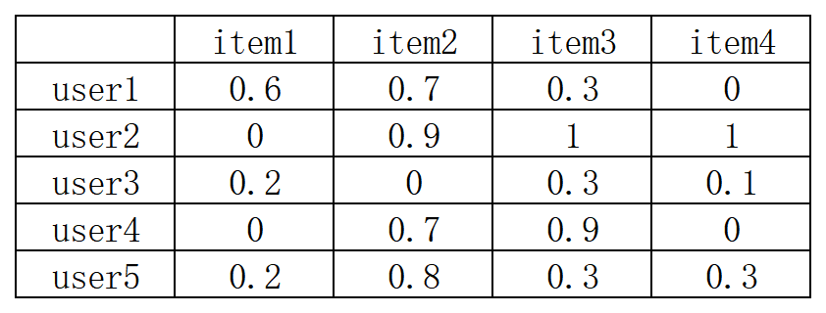
Figure 1 User–item interaction matrix (simulated data) for 5 users and 4 items. Each cell represents the user’s preference score for the corresponding item.
For example, we can represent the preference score of all users for item 1 as a vector [0.6,0,0.2,0,0.2]. Similarly, the preference score vector for item 2 can be obtained as [0.7,0.9,0,0.7,0.8]. According to equation (1), the cosine similarity between these two items can be computed as follows:
$\frac{0.6×0.7+0×0.9+0.2×0+0×0.7+0.2×0.8}{\sqrt{{0.6}^{2}+{0.2}^{2}+{0.2}^{2}}×\sqrt{{0.7}^{2}+{0.9}^{2}+{0.7}^{2}+{0.8}^{2}}}=0.56$ (2)
The cosine similarity between item 1 and item 2 is thus 0.56, indicating that if all users’ ratings for the two items were exactly the same, the cosine similarity would reach 1. Likewise, if necessary, we can compute user–user similarity in the same way, by representing each user as a vector of ratings for all items.
However, this form of representation has a major drawback: in a database with tens of millions of users and items, the corresponding vectors must also be in the tens of millions of dimensions. This poses a significant burden on both storage and computational resources. Moreover, most users have no interactions with most items, meaning that the interaction matrix is inherently sparse, leading to substantial inefficiency and resource waste.

2.2.1.1.3 Adjusted Cosine Similarity
In the previous similarity calculations, one easily overlooked issue is that different users may have varying rating habits — some tend to rate more generously, while others are more conservative. For example, a certain user might often give scores of 100, and a score of 99 already indicates dissatisfaction. In contrast, another user might usually give scores around 50, and a score of 60 would reflect satisfaction.
To address this discrepancy, an improved method for calculating similarity has been proposed:
$\text{sim}\left(i,j\right)=\frac{\sum_{u∈U}{\left(R_{u,i}-{\overline{R}}_{u}\right)\left(R_{u,j}-{\overline{R}}_{u}\right)}}{\sqrt{\sum_{u∈U}{{\left(R_{u,i}-{\overline{R}}_{u}\right)}^{2}}}⋅\sqrt{\sum_{u∈U}{{\left(R_{u,j}-{\overline{R}}_{u}\right)}^{2}}}}$ (2)
Here, $R_{u,i}$​ represents the rating given by user u to item i, and ${\overline{R}}_{u}$​ denotes the average rating that user u has given across all items. It can be observed that this approach still essentially follows the basic idea of cosine similarity, but with additional processing and normalization of the ratings. Specifically, for each rating given by a user, the user’s average rating is subtracted before participating in the calculation. This normalization step is intended to offset differences in individual rating habits.

2.2.1.1.4 Dot Product Similarity
Similar to cosine similarity, but without normalization. This approach has both clear advantages and disadvantages.
The advantage is that the similarity measure takes into account not only the direction (structure) of the vectors but also their magnitude (intensity), meaning both the angle and the length of the vectors are considered.
The disadvantage, however, is that it becomes difficult to determine whether the similarity between two items is due to strong signals in just a few dimensions, or because the overall structure of the vectors is well aligned.
$\text{sim}\left(i,j\right)=\cos\left(\vec{i},\vec{j}\right)=\vec{i}⋅\vec{j}$ (2)

2.2.1.1.5 prediction
$P_{u,i}=\frac{\sum_{\text{all similar items }N}{\left(s_{i,N}⋅R_{u,N}\right)}}{\sum_{\text{all similar items }N}{\left(\left|s_{i,N}\right|\right)}}$ (2)
After obtaining the similarity scores, the next step is to compute the final preference score $P_{u,i}$ of user u for item j. This is typically achieved via a weighted average, where the similarity between each interacted item N and item j is multiplied by the user's rating for item N, summed over all similar items, and then normalized by the sum of the similarity values. This approach, which aggregates contributions from all relevant items proportionally to their similarity, is one of the most widely used prediction strategies in collaborative filtering.

2.2.1.2 Matrix Factorization (MF)
Matrix Factorization (MF) was originally proposed as a mathematical technique to address the challenges of operating on high-dimensional and sparse matrices (Koren et al., 2009). In its classical form, MF decomposes a large user–item rating matrix $R∈R^{m×n}$ into the product of two lower-dimensional matrices, sacrificing a small amount of information to obtain a compact representation and reduce computational complexity. This decomposition is typically carried out using closed-form mathematical methods such as Singular Value Decomposition (SVD) or Principal Component Analysis (PCA).
In modern recommender systems, the MF concept has evolved beyond explicit matrix decomposition. Instead of applying a one-off mathematical operation, two trainable matrices $P∈R^{m×f}$ and $Q∈R^{n×f}$ are initialized, where each row of P represents a user vector capturing latent preferences, and each row of Q represents an item vector capturing latent characteristics. These matrices are jointly optimized, typically via stochastic gradient descent, so that their product approximates the original sparse rating matrix.
Importantly, even when training is performed exclusively on observed ratings — i.e., only for user–item pairs with explicit interactions — the learned latent factor space enables the model to assign scores to previously unseen user–item combinations. This predictive capability arises because the latent factors capture generalizable patterns of user preferences and item characteristics, allowing the system to make recommendations beyond the training data.
The difference between traditional mathematics-based MF and its model-based, trainable counterpart is illustrated in Figure2. The figure highlights that while the traditional approach directly applies mathematical factorization methods (e.g., SVD, PCA) to produce the two factor matrices, the model-based approach treats these matrices as learnable parameters and optimizes them iteratively to minimize prediction error. This transition from closed-form decomposition to learnable-parameter optimization has significantly expanded MF’s flexibility and integration potential with other machine learning models.
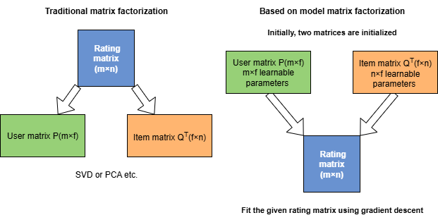
Figure 2 illustration of the difference between traditional and model-based matrix factorization methods

2.2.1.3 DSSM(Deep Structured Semantic Model) and Two-Tower Model
Deep Structured Semantic Model (DSSM) was originally developed for document retrieval, where the goal is to map queries and documents into a common semantic vector space so that semantically related pairs are close together. This is achieved by encoding each input (e.g., a user query or an item/document) into an embedding vector through a deep neural network, and computing similarity between embeddings (e.g., cosine similarity) to rank candidates.
In modern recommender systems, DSSM has inspired the widely used Two-Tower Model architecture. In this setting, user and item embeddings are learned separately by two neural networks: one tower processes user IDs and features to produce the final user embedding, while the other processes item IDs and features to produce the final item embedding. During training, positive and negative user–item pairs are sampled based on historical interactions, and the model is optimized to assign higher similarity scores to positive pairs.
Once trained, the user and item embeddings can be precomputed and stored. At inference time, a given user's embedding is used to efficiently retrieve the most similar items in the item embedding space, and the top-N items are recommended as the most relevant results.
Figure 3 illustrates the overall process of the Two-Tower Model, including the separate user/item embedding networks, the training workflow, and the inference stage. 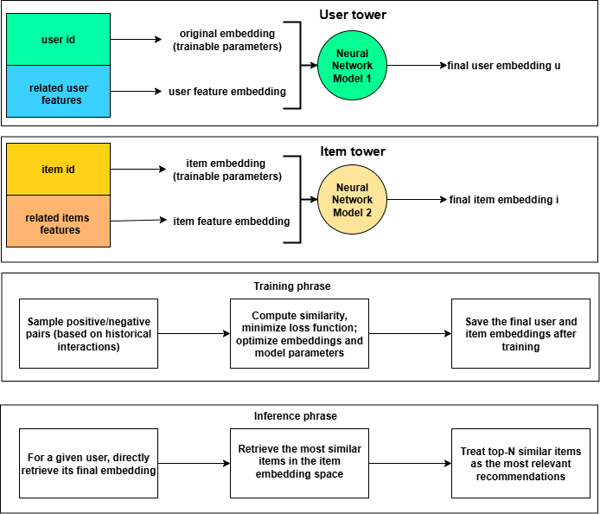
figure 3 Overview of the Two-Tower Model inspired by DSSM, including separate user/item embedding networks, the training process, and inference phase for retrieving and ranking top-NNN recommendations.

2.2.1.4 LightGCN (Light Graph Convolutional Network)
In user–item interaction scenarios, the relationships can naturally be modeled as a bipartite graph, where users and items are represented as nodes, and interactions are represented as edges. Graph Neural Networks (GNNs) have therefore become a popular framework for recommendation, with Neural Graph Collaborative Filtering (NGCF) being a representative early model.
While NGCF incorporates feature transformations, non-linear activations, and high-order neighborhood aggregation to enhance interaction modeling, subsequent studies have shown that such complexity may not always yield better performance. LightGCN was proposed as a simplified yet effective alternative, retaining only the core idea of neighborhood aggregation.
In LightGCN, user and item embeddings are updated by aggregating the embeddings of their neighbors in the interaction graph across multiple hops, without applying feature transformations or non-linearities. This design reduces overfitting risk, improves computational efficiency, and has been shown to perform competitively or even better than more complex GNN-based recommenders.
After KKK layers of propagation, the final embedding for a node is obtained by combining its representations from all layers, weighted by learnable or predefined coefficients. By aggregating multi-hop neighborhood information in this way, LightGCN captures both direct and high-order collaborative signals with minimal model complexity, resulting in a lightweight yet highly effective recommendation method.
As illustrated in Figure 4, we consider a toy example with two users$\left(u_{1},u_{2}\right)$ and two items $\left(i_{1},i_{2}\right)$, each initialized with a learnable embedding vector at time $t_{0}$. LightGCN performs the same update operation for all nodes: the embedding of each node at the next time step is computed as the normalized sum of the embeddings of its neighbors, where normalization mitigates the influence of varying node degrees (i.e., popularity bias). This update yields the embeddings at time $t_{1}​$, representing the result of one propagation step.
By repeating this procedure for K steps, information can be propagated across increasingly distant neighbors. The objective is to make embeddings of highly related users and items as similar as possible—this propagation mechanism directly enforces this principle by making connected nodes more alike with each step.
Finally, embeddings from different propagation depths are combined through a weighted sum to form the final embedding. For example, the final representation of $u_{1}​$ can be expressed as
$u_{1}^{(final)}​=α⋅u_{1}^{{(t}_{0})}​​+\left(1-α\right)⋅u_{1}^{(t_{1})​}​$ (2)
where $α$ is a weight that can be either pre-defined or learned during training. This design is akin to the residual connections in deep networks, allowing each layer to preserve information from neighbors at multiple hop distances and potentially improving the richness of the learned representations.
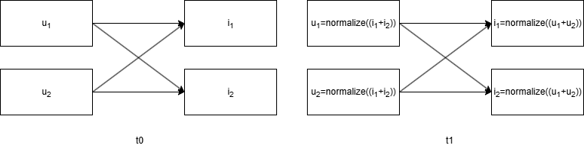
figure 4 Example of one-step embedding propagation in LightGCN, where each node updates its embedding by aggregating and normalizing its neighbours’ embeddings.

2.2.1.5 GRU4Rec (Gated Recurrent Unit for Recommendation)
In this section, we introduce methods that model user–item interactions as sequences, motivated by the observation that user behaviors are often temporally dependent rather than independent and identically distributed. In many real-world applications—such as e-commerce or media streaming—a user’s next actions are influenced by recent activity. Modeling session-level behavior can therefore be an effective way to improve recommendation performance, especially when long-term user identifiers are unavailable or historical data is limited.
Session-based recommendation treats each session as an independent interaction sequence, using the order of clicks or interactions to infer user intent and predict the next item based on the preceding interactions. Recurrent Neural Networks (RNNs) are a natural choice for this task, as they can process variable-length sequences and capture temporal dependencies. However, standard RNNs often suffer from vanishing gradients, which hinder their ability to model long-range dependencies within a sequence.
To overcome this limitation, Hidasi et al. (2015) proposed GRU4Rec, which employs Gated Recurrent Units (GRUs) in the session-based recommendation setting. GRUs introduce gating mechanisms that control the flow of information, enabling the network to selectively retain or discard historical context and thus better capture dependencies across multiple time steps. In GRU4Rec, each session is processed independently, and the model is trained with pairwise ranking objectives. In addition to the widely used Bayesian Personalized Ranking (BPR) loss, the authors proposed the TOP1 loss, which places additional emphasis on enlarging the score margin between positive (clicked) and negative (non-clicked) items.
While session-based methods focus on modeling short-term preferences within each session, the use of GRUs enhances the model’s capacity to capture longer-term dependencies inside that session, improving its ability to predict the next likely item.

2.2.1.6 SASRec (Self-Attentive Sequential Recommendation)
Self-attention mechanisms, which have achieved notable success in areas such as natural language processing and machine translation, have recently been introduced to recommender systems for modeling sequential user–item interactions. SASRec, proposed by Kang et al. (2018), leverages self-attention to capture both short- and long-range dependencies within user behavior sequences, enabling the model to attend to the most relevant past interactions when predicting future ones.
Given a user’s interaction sequence of length nnn, each item is represented as an embedding vector $M_{s_{k}}$and augmented with a learnable positional embedding$P_{k}$​ to preserve order information:
$$\hat{E}={\left[M_{s_{1}}+P_{1}, M_{s_{2}}+P_{2}, …, M_{s_{n}}+P_{n}\right]}^{⊤}, \hat{E}∈R^{n×d}$$
These enriched embeddings are processed through the standard self-attention mechanism:
$$\text{Attention}\left(Q,K,V\right)=\text{softmax}\left(\frac{QK^{⊤}}{\sqrt{d}}\right)V$$
where Q, K, and V are obtained via learnable linear transformations of the input embeddings. This operation allows each position in the sequence to attend to other positions, capturing global contextual relationships.
The outputs of the self-attention layers are passed through position-wise feed-forward networks (FFN), combined with residual connections, layer normalization, and dropout to enhance expressiveness and mitigate overfitting. Multiple self-attention blocks can be stacked to increase the model’s capacity to capture complex dependency patterns.
For prediction, SASRec computes the similarity between the learned representation of the current sequence and candidate item embeddings (e.g., via inner product), followed by a ranking-oriented loss. Kang et al. (2018) adopt a binary cross-entropy loss, encouraging positive (interacted) items to receive higher scores than negative samples:
$$-\sum_{s^{u}∈S}{\sum_{t}{\left[\log{σ}\left(r_{o_{t},t}\right)+\sum_{j∉S^{u}}{\log\left(1-σ\left(r_{j,t}\right)\right)}\right]}}$$
where r denotes the predicted relevance score, $o_{t}$​ is a positive item at position t, and j indexes negative items.
By replacing recurrent architectures with self-attention, SASRec offers parallel computation, improved efficiency, and flexible modeling of both recent and distant dependencies, making it a strong choice for large-scale sequential recommendation tasks.

2.2.4 Loss Function
Among the various recommendation algorithms currently in use, two of the most widely adopted loss functions are Bayesian Personalized Ranking (BPR) loss and In-batch Softmax loss. The following sections provide a detailed explanation of each.

2.2.4.1 Bayesian Personalized Ranking (BPR) loss
Bayesian Personalized Ranking (BPR) (Rendle et al., 2012) is a pairwise ranking loss function designed for implicit feedback recommendation. In many real-world scenarios, only implicit user interactions—such as clicks, views, or purchases—are available. BPR assumes that for a given user u, any observed item i is preferred over any unobserved item j, denoted as $i≻_{u}j$.
The preference probability is modeled using a logistic sigmoid over the score difference:
$$p\left(i≻_{u}j ∣ Θ\right)σ=\left({\hat{x}}_{uij}\right), {\hat{x}}_{uij}=\text{score}\left(u,i\right)-\text{score}\left(u,j\right)$$
Where $σ\left(x\right)=\frac{1}{1+e^{-x}}$ ​. The BPR loss maximizes the summed log-likelihood over all training triples $\left(u,i,j\right)$, with an $L_{2}​$regularization term on parameters:
$$\text{BPR loss} \text{=}-\sum_{\left(\text{u,i,j}\right)\text{∈}{\text{D}}_{\text{S}}}{\text{ln}{\text{σ}}\left({\hat{\text{x}}}_{\text{uij}}\right)}\text{+}{\text{λ}}_{\text{Θ}}\text{|}\text{Θ}{\text{|}}^{\text{2}}$$
This formulation directly optimizes for ranking consistency—ensuring that positive items are scored higher than negatives—without requiring explicit ratings, making it particularly effective for large-scale implicit feedback recommendation.

2.2.4.2 In-batch Softmax Loss
In-batch Softmax Loss was first proposed and implemented by Matthew Henderson et al. (2017), and its definition is relatively straightforward:
$$In-batch Softmax Loss =-\frac{1}{K}\sum_{i}{\log\left(\frac{e^{S\left(x_{i},y_{i}\right)}}{\sum_{j}{e^{S\left(x_{i},y_{j}\right)}}}\right)}$$
Here, x and y denote paired embedding vectors, and $s\left(x_{i},y_{j}\right)$ a similarity score (e.g., dot product or cosine similarity) between $x_{i}​$and $y_{j}$. The denominator forms a classic softmax structure, normalizing scores across the batch. K is the number of positive pairs in the batch.
This loss is particularly well-suited for recommendation systems. It enables the model to distinguish a user's true positive item from a large pool of candidates by computing similarities between the user's embedding and all item embeddings in the same batch. By normalizing via Softmax, it encourages the model to assign higher similarity to the correct item.
Compared with BPR, which constructs training samples as triplets (u, i, j) In-batch Softmax can implicitly treat all other items in the batch as negatives. This makes it highly efficient and scalable, especially when constructing negative samples is costly. Moreover, it provides a more principled way to simulate a large candidate item space during training, mitigating the sample sparsity issue commonly seen in implicit feedback datasets.

2.2.5 Approximate Nearest Neighbor Search (ANN) Methods and FAISS
A common scenario in recommender systems is retrieving the top-N most similar items from a large item corpus given a user embedding. The most straightforward approach is to compute the similarity between the user vector and every item vector in the database, and then return the top-N items with the highest similarity scores. However, in real-world industrial settings or large-scale systems, this exhaustive computation becomes infeasible due to its high computational cost, and it cannot meet the real-time requirements of recommendation tasks.
To address this issue, Approximate Nearest Neighbor (ANN) Search methods are commonly adopted. ANN encompasses a family of algorithms designed to efficiently retrieve vectors that are close to a given query vector, by trading off a small amount of accuracy for a significant gain in speed. These methods typically involve techniques such as hashing, quantization, re-encoding, and index construction to store vectors in a way that enables fast querying (Andoni et al., 2018).
In this study, we adopt FAISS, an ANN-based library developed by Facebook AI Research, to build indexes and perform similarity search. With distributed computation and optimized indexing strategies, FAISS can scale to extremely large datasets and has demonstrated the ability to search over 1.5 trillion vectors in under one second (Douze et al., 2024).

Section 2.3. Choice of methods (or another appropriate title)
I chose to implement five representative retrieval algorithms and experimented with using In-batch Softmax Loss as the loss function during training. Additionally, I applied FAISS as the tool for nearest neighbor search. Below, I detail the reasoning behind these choices:

2.3.1 Algorithm Selection
I selected five widely used and representative retrieval algorithms, which are commonly adopted by various datasets as baselines. In fact, the dataset I used already includes these five algorithms as official baselines, which makes my selection comparably valid and allows me to evaluate the quality of my training in a meaningful way.

2.3.2 Why In-batch Softmax Loss
Initially, I attempted to use BPR (Bayesian Personalized Ranking) loss as the training objective. This loss requires, for every input, at least one negative sample, encouraging the model to predict scores closer to the positive item and farther from the negative one. While this method is theoretically sound and has been widely adopted in research papers, I encountered several practical issues:
Negative Sampling Strategy. Choosing appropriate negative samples proved challenging. Should they be selected randomly? Should a correction factor be applied to balance out popular items? (Without correction, random sampling tends to favor popular items simply due to their higher overall occurrence.)
I experimented with various strategies — sampling one negative item, sampling ten, applying popularity correction, and using purely random sampling — but found two major problems:
Firstly, The impact of sampling strategy on performance was non-linear. Using ten negatives did not significantly outperform using one. Surprisingly, applying corrected sampling led to results very close to a baseline that simply recommends the most popular items, suggesting the model began to favor globally popular content regardless of user profile.
Secondly, Negative sampling was a CPU-bound, compute-intensive task. It could not be efficiently accelerated on GPU. Each iteration required scanning the dataset and randomly selecting negative items that do not appear in the user’s interaction history. To avoid overfitting, it’s crucial to sample different negatives per epoch, demanding high CPU usage.
For large-scale datasets, this becomes a bottleneck: training with 1 million positive samples requires generating 1 million negatives per epoch, totaling 10 million sampling operations over 10 epochs. Because each negative must be validated against user history, it’s difficult to batch or pre-generate these samples, making this process a major slowdown in training.
Instead, Switching to In-batch Softmax Loss led to significant improvements in both training speed and accuracy. It eliminated the need for explicit negative sampling, making the training pipeline much more efficient.

2.3.3 Use of Nearest Neighbor Search (FAISS)
Although my current dataset is not large enough to require nearest neighbor search, I still implemented it using FAISS to ensure the model can scale to industrial-level applications. In real-world scenarios, the system must match users with the most relevant videos in real time, which makes fast vector search essential. FAISS enables efficient indexing and retrieval of embedding vectors, preparing the system for deployment at scale.

2.3.4 Choice of Similarity Function
I chose to use dot product as the similarity measure instead of cosine similarity, which some papers prefer. Although dot product has a theoretical risk of overfitting due to large vector norms, I observed that when combined with In-batch Softmax Loss, this risk was minimal (further discussed in the results section).
Moreover, dot product led to faster convergence during training compared to cosine similarity, which further justified its selection in my implementation.

Chapter 3 Datasets and Experimental Design

Section 3.1 Datasets/Data Sources
The dataset I selected is Microlens, released by Westlake University. It includes user–video interaction records, video cover images, and video title information. The dataset contains 352,649 interaction records, 50,000 users, and 19,220 videos. Its moderate size makes it suitable for quickly validating model effectiveness in the early stages. In addition, it includes some item-side information, such as images and titles, which facilitates the use of multimodal information.
(Planned, not yet used): The Tenrec dataset, released by Tencent, contains 38,300,254 interaction records and 1,000,000 users. Compared to Microlens, it offers nearly 100 times more data, enabling evaluation of model performance on large-scale datasets. Furthermore, Tenrec provides rich user-side information, which opens up possibilities for addressing the cold-start problem. Its scale also introduces new demands for data processing, making it a suitable benchmark for evaluating performance optimization strategies on large datasets.
(Planned, but uncertain, depending on available time and resources.)

Section 3.2. Experimental Design

3.2.1 Data Preprocessing
3.2.1.1 common data procedure
1. Random Seed Initialization
To ensure reproducibility and maintain the stability of training outcomes, a fixed random seed of 42 was applied across all relevant components. Specifically, this included the Python built-in random number generator, NumPy random number generator, PyTorch CPU-based random numbers, CUDA’s manual_seed for GPU computations, and deterministic settings for cuDNN algorithms.
2. Sorting Interaction Records
Given that certain experiments require strict temporal ordering, interaction records were preprocessed by sorting them in ascending order based on user ID and timestamp. This step standardises the preprocessing pipeline and ensures that the temporal structure of user interactions is preserved.
3. Filtering Users and Items with Sparse Interactions
To ensure that the training data is informative and of high quality, users and items with very few interactions were excluded. Specifically, any user or item with fewer than three total interactions was removed from the dataset.
4. Dataset Splitting
Following a commonly adopted approach in the recommender systems literature, the last recorded interaction of each user was allocated to the test set, while all preceding interactions formed the training set. Initially, an attempt was made to construct a validation set by extracting each user’s penultimate interaction from the data set. This approach aimed to facilitate hyperparameter tuning and early stopping. However, it was observed that the validation set—being temporally close to the last interaction—was overly predictive of the test set, leading to a substantial performance drop (approximately 50%) when predicting the test set using only the training set. Consequently, the validation set was omitted, and the dataset was divided exclusively into training and test sets.
5. Filtering the Test Set
The test set was further refined by removing any interactions involving users or items that did not appear in the training set. This ensures that all entities in the test set have been observed during training, avoiding cold-start issues.
6. Re-indexing User and Item Identifiers
Since the dataset originates from multiple sources, user and item IDs were not guaranteed to be sequential. Given that PyTorch embedding layers index items sequentially, all IDs were re-encoded into continuous integer sequences. A hash mapping was created and stored to preserve the correspondence between the original IDs and the new indices.
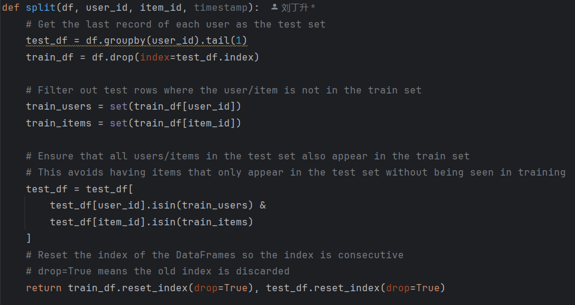
Figure 5 Procedure for Train–Test Split in User–Item Interaction Data
3.2.1.2 Multimodal Data Preprocessing
1. Processing Visual Modality
The cover image of each video was processed using OpenAI’s CLIP model to obtain a 512-dimensional feature vector. To reduce computational overhead in subsequent model training, the vectors were further reduced to 128 dimensions using Principal Component Analysis (PCA) and stored in an LMDB database—a file-based key–value vector store—with the item ID as the key and the reduced vector as the value. PCA was selected primarily to decrease processing time and accelerate training. Empirical evaluation showed that the recommendation performance using PCA-reduced vectors exhibited no significant degradation compared to the original 512-dimensional representation.
2. Processing Textual Modality
The title text of each item was embedded using the BAAI/bge-large-en-v1.5 model, yielding a 1024-dimensional representation. These vectors were stored in the LMDB database, keyed by item ID. Unlike the visual features, no dimensionality reduction was applied to the textual vectors. Retaining the full 1024 dimensions increased the overall training time by approximately twofold compared to concatenating them with the 128-dimensional visual vectors. However, given that training was conducted on Google Colab with an NVIDIA A100 GPU and the dataset size was relatively small, training speed remained acceptable; thus, dimensionality reduction for textual features was deemed unnecessary.
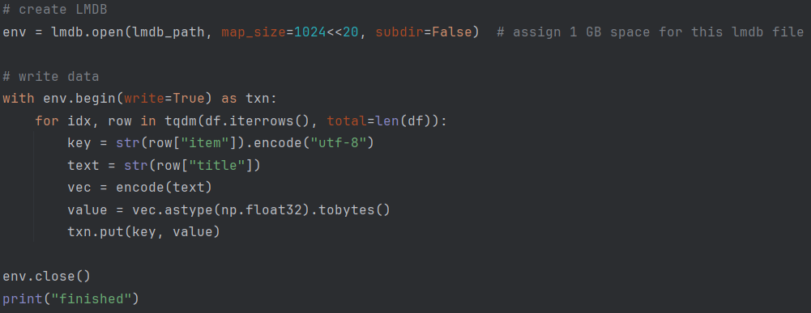
Figure 6 Procedure for encoding and storing item title embeddings in LMDB.

时序信息预处理
在处理时序信息时，有两个问题，第一个问题，一个是我们需要连续的输入，尤其对于GRU来说。如果我们想预测第n个物品，需要先输入第一个物品信息，等待结果返回后在输入第二个物品信息，重复这个过程，直到输入完第n-1个物品信息后等待返回值，藉此预测第n个物品。这使得整个训练难以并行化处理，极大拖慢训练速度（SASRec利用位置编码和自注意力机制可以同时捕捉全局信息和位置信息，不需要串行输入）
首先对于第一个问题，我们对原有数据进行如下预处理：将某用户的原有n个交互信息，转化为n-1个(input,target)。首先将第一个视频单独作为集合，target设置为第二个视频。然后将target移入输入集合，将target向后挪动一个时间步。反复循环，我们得到了训练数据和他们的正样本值。如图所示：
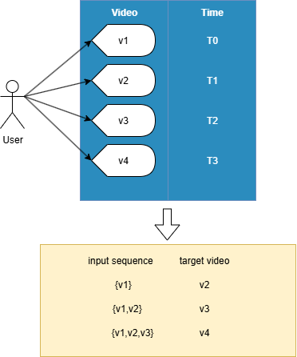
Figure 7 转换训练集从用户-视频对，变为前序序列和目标视频
通过对每个用户如Figure7 所示进行处理，对原有的数据集进行了重构，由每个数据1用户对应1视频的关系变更为了一组视频对应一个目标视频的关系。如此我们实现了并发允许的基础，不管是同一个用户的不同input sequence-target video还是不同用户间的任意input sequence-target video均可以互不干扰的并行处理。但这又引发了一个不便，即每个session有不同的长度，无法控制不同输入同时开始和结束，不符合传统数据加载的原则，即统一加载，统一处理，统一返回。
这就引出了第二个问题，即不同会话（或者说对于每个用户来说）交互的视频数量不同，有些数量庞大，有的数量稀少，为了统一输入，统一计算结果，简化和加速训练，我们往往指定固定的时间步数。对于较长的session，我们截取最近的指定数量的视频，而对于较短的session，我们使用padding来进行填充。则上图可以变更为如下：
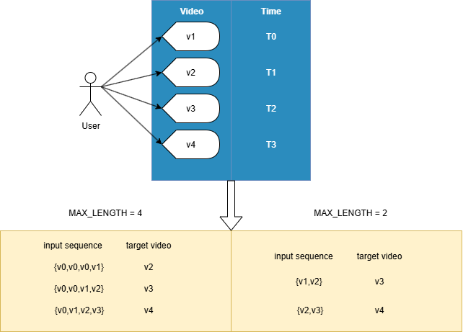
Figure 8 添加填充和最大时间长度后的输入序列和目标值
如果Figure 8 所示，此时v0为人为添加用于填充序列的虚拟视频，其嵌入通常设定为0向量且不可变更，通过限制MAX_LENGTH和增加padding，同一个用户的不同预测位置和不同用户间的任意预测位置有了统一的长度，非常适于并行化的数据载入，前向传播，目标值匹配，梯度下降。s

3.3 Model Architecture

3.3.1 Baseline Models
Implement the four selected algorithms: LightGCN, DSSM, GRU4Rec, SASRec.
LightGCN:
Construct the auxiliary matrix (Xiangnan He et al., 2020) using matrix operations to perform message passing, which allows faster computation.
Construct matrix A = $[\begin{matrix}0 & R \\ R^{T} & 0\end{matrix}]$, where RRR is the user–video interaction matrix. The rows of R represent the user IDs after behavior matrix encoding, and the columns represent the video IDs after re-encoding. If there is an interaction, the value is set to 1; otherwise, it is 0.
Then perform normalization as follows:

$\hat{A} =D^{-1/2}​AD^{-1/2}$​
D denotes the degree matrix, which is a diagonal matrix. Each diagonal entry $D_{ii}$​ equals the degree of node i, i.e., the number of edges connected to node i. With this matrix, normalization can be applied to the adjacency matrix to balance the influence of nodes in the graph.
Next, define the embedding dimension. The user and item embeddings are initialized randomly, with the dimension:
E=user number + item number
Only the interactions in the training set are retained, and A⋅E is performed for each iteration. The final formula is as follows:
Required hyperparameters: epoch count, batch size, number of layers, learning rate, user embedding dimension, item embedding dimension.

DSSM:
For videos and users respectively, independent multi-layer MLPs are built. After passing through the model, the final user and video embeddings are obtained separately, and then fed into the evaluation module.
Required hyperparameters: number of epochs, batch size, learning rate, MLP architecture for both user and video branches, including number of layers, hidden dimensions, and output dimension.
GRU4Rec
The training set is additionally preprocessed: for any user’s sequence $\{i_{1},i_{2},…,i_{n-1}\}→i_{n}$. The specific transformation is described in the methodology section.
Required hyperparameters: number of epochs, batch size, learning rate, item embedding dimension, GRU hidden size, special PADDING ID (used when the input sequence has fewer than n items — the empty positions at the beginning are filled with the PADDING ID).

SASRec
Similar to GRU4Rec, the input data for training is processed in the same way.
Required hyperparameters: number of epochs, batch size, learning rate, item embedding dimension, special PADDING ID (used when the input sequence has fewer than nnn items — the empty positions at the beginning are filled with the PADDING ID), number of attention heads, and number of stacked self-attention layers.

3.3.2 Multi-modal Extension
To investigate the impact of multimodal information on recommendation performance, we extend the baseline models by integrating additional content features. Specifically, we explore the effect of concatenating the following pre-trained embeddings either prior to or after the core recommendation model:
- A 128-dimensional video thumbnail embedding obtained via a pre-trained CLIP model (OpenAI).
- A 128-dimensional video title embedding derived from a language model.
- A joint concatenation of both the thumbnail and title embeddings, forming a 256-dimensional multimodal feature vector.
These configurations aim to assess whether visual and textual cues can enhance user preference modeling and improve overall recommendation accuracy.

3.3.3 Mitigating the Cold Start Problem with Multimodal Information
To address the cold start problem, we transfer the optimal model architecture and hyperparameter configuration obtained from the smaller MicroLens dataset to the larger-scale Tenrec dataset. We repeat the multimodal integration strategies described above to evaluate their scalability and generalizability.
Furthermore, we train an additional MLP model to learn a mapping from user profile features to user embedding vectors, allowing us to evaluate the recommendation performance in cold-start scenarios where behavioral interaction data is unavailable and only user attributes are accessible.

3.4 Evaluation Design
- Metrics:
  - Hit Ratio@K (HR@K): Measures whether the ground truth test item appears in the Top-K recommendations.
  - Normalized Discounted Cumulative Gain@K (NDCG@K): Takes into account the ranking position of the correct item — higher ranks receive higher scores.
- Baseline Setup: Use two baseline methods — Random recommendation and Popularity-based recommendation.
- Evaluation Steps:
  - Store the user and item final embeddings generated after training.
  - Store item vectors using FAISS for fast nearest neighbor search.
  - For each user in the test set, retrieve their corresponding user embedding and find the Top-K most similar item vectors using FAISS.
  - Treat these K items as predicted recommendations.
  - Check if the ground truth item is among the Top-K and compute HR@K and NDCG@K accordingly.

Chapter 4 Results of the Empirical Investigation
4.1 Experimental Results on Dataset MicroLens.
4.2 Experimental Results on Dataset Tenrec.
4.3 Comparison of Single-modal and Multi-modal Models
4.4 Hyperparameter Sensitivity Analysis

Chapter 5 Evaluation of results

Chapter 6 Conclusions and Future Work

References
We Are Social and Meltwater. (2025) Digital 2025 April Global Statshot Report. Available at: https://datareportal.com/reports/digital-2025-april-global-statshot (Accessed: 9 August 2025).
Omdia. (2025) TikTok and YouTube Dominate Video Platforms for Millennials and Gen Z in the USA. Available at: https://omdia.tech.informa.com/pr/2025/jan/tiktok-and-youtube-dominate-video-platforms-for-millennials-and-gen-z-in-the-usa (Accessed: 9 August 2025).
Goldberg, D., Nichols, D., Oki, B.M. and Terry, D. 1992. Using collaborative filtering to weave an information tapestry. Communications of the ACM. 35(12), pp.61–70.
Gifford, D.K., Baldwin, R.W., Berlin, S.T. and Lucassen, J.M. An architec- ture for large scale information sys- tems. In Proceedings Tenth Symposium on Operating Systems Principles (Orcas Island, Wash., Dec. 1985), pp. 161- 170.
Resnick, P., Iacovou, N., Suchak, M., Bergstrom, P. and Riedl, J. 1994. GroupLens: an open architecture for collaborative filtering of netnews In: CSCW `94: Computer Supported Cooperative Work Proceedings Held in Chapel Hill, N. C. November 22-26, 1994. New York, NY, USA: ACM, pp.175–186.
Linden, G., Smith, B. and York, J. 2003. Amazon.com recommendations: item-to-item collaborative filtering. IEEE internet computing. 7(1), pp.76–80.
Koren et al., 2009, Matrix Factorization Techniques for Recommender Systems
Huang, P.-S., He, X., Gao, J., Deng, L., Acero, A. and Heck, L. 2013. Learning deep structured semantic models for web search using clickthrough data In: Proceedings of the 22nd ACM international conference on Information & Knowledge Management. New York, NY, USA: ACM, pp.2333–2338.
Hidasi, B., Karatzoglou, A., Baltrunas, L. and Tikk, D. 2015. Session-based Recommendations with Recurrent Neural Networks.
Kang, W.-C. and McAuley, J. 2018. Self-Attentive Sequential Recommendation.
Sarwar, B., Karypis, G., Konstan, J. and Riedl, J. 2001. Item-based collaborative filtering recommendation algorithms In: Proceedings of the 10th international conference on World Wide Web. New York, NY, USA: ACM, pp.285–295.
Koren, Y., Bell, R. and Volinsky, C. 2009. Matrix Factorization Techniques for Recommender Systems. Computer (Long Beach, Calif.). 42(8), pp.30–37.
Liu, Q., Zheng, K., Huang, R., Li, W., Cai, K., Chai, Y., Niu, Y., Hui, Y., Han, B., Mou, N., Wang, H., Bao, W., Yu, Y., Zhou, G., Li, H., Song, Y., Lian, D. and Gai, K. 2024. RecFlow: An Industrial Full Flow Recommendation Dataset.
Wang, S. 2023. Methodologies for Improving Modern Industrial Recommender Systems.
Henderson, M., Al-Rfou, R., Strope, B., Sung, Y., Lukacs, L., Guo, R., Kumar, S., Miklos, B. and Kurzweil, R. 2017. Efficient Natural Language Response Suggestion for Smart Reply.
Wang, X., He, X., Wang, M., Feng, F. and Chua, T.-S. 2019. Neural Graph Collaborative Filtering In: Proceedings of the 42nd International ACM SIGIR Conference on Research and Development in Information Retrieval. New York, NY, USA: ACM, pp.165–174.
He, X., Deng, K., Wang, X., Li, Y., Zhang, Y. and Wang, M. 2020. LightGCN: Simplifying and Powering Graph Convolution Network for Recommendation In: Proceedings of the 43rd International ACM SIGIR Conference on Research and Development in Information Retrieval. New York, NY, USA: ACM, pp.639–648.
Andoni, A., Indyk, P. and Razenshteyn, I. 2018. Approximate Nearest Neighbor Search in High Dimensions.
Douze, M., Guzhva, A., Deng, C., Johnson, J., Szilvasy, G., Mazaré, P.-E., Lomeli, M., Hosseini, L. and Jégou, H. 2024. The Faiss library.
Hidasi, B., Karatzoglou, A., Baltrunas, L. and Tikk, D. 2015. Session-based Recommendations with Recurrent Neural Networks.

